Project Updates and Progression
Intended website link: https://www.fmorafa.com
Sitemap UML Diagram
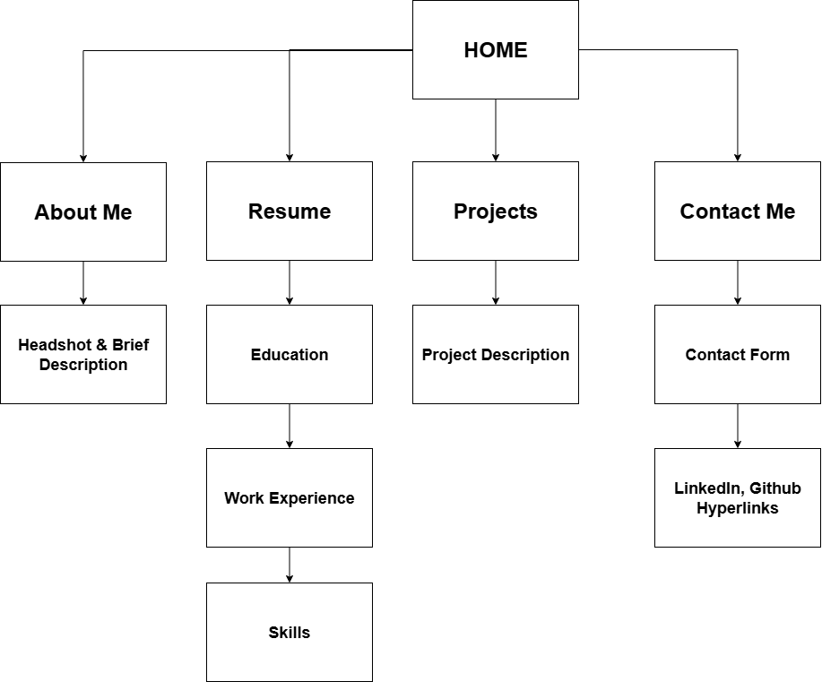

Website Construction Recap
For my midterm project, I developed an alpha version of my personal portfolio website using IONOS.com, a paid hosting platform that supports PHP, MySQL and MariaDB. The goal of the project was to create a professional online presence that represents my academic background, skills, and experience in computer science while demonstrating technical proficiency in HTML, CSS, JavaScript, and PHP without using any frameworks or templates.
Hosting and File Organization
After evaluating several hosting options, I selected IONOS.com because it provides reliable support for PHP scripting and MySQL databases. I created an account, configured the domain, and uploaded my files through the file manager. My project follows a clean folder structure, including directories for CSS, JavaScript, images, and PHP scripts, ensuring an organized and maintainable layout. A screenshot will be displayed below to show the website’s hierarchical structure and layout.
Website Pages and Design
The site currently includes three completed pages: Home, About Me, and Resume, all linked through a consistent navigation bar. The Home page serves as the main landing page with a headshot, introduction, and links to other sections. The About Me page describes my academic journey and technical interests. The Resume page highlights my education, experience, and programming skills, organized into structured sections for readability. All pages share a unified layout through a single external CSS file, using classes and IDs to control appearance while avoiding inline styles. The design focuses on simplicity, professionalism, and responsive layout elements through the use of CSS Flexbox and Grid.
Navigation, Interactivity, and JavaScript
A <nav> element is utilized to build a consistent navigation bar that appears on every page. The navigation bar features hover effects and highlights the active page to improve user experience. JavaScript adds interactivity, such as smooth scrolling and responsive behavior for smaller screens, ensuring usability across devices. These scripts demonstrate practical client-side functionality while keeping the website lightweight and efficient.

Database Integration
The website incorporates a MySQL database connected through PHP. I created the database using IONOS’s control panel and populated it with sample data for my skills and experience sections. The Resume page dynamically retrieves and displays this data using PHP queries, illustrating how static pages can be enhanced through dynamic, database-driven content. This feature confirms a successful backend integration and presents the necessary data from a database.
Reflection
Building the site from scratch allowed me to strengthen my understanding of both frontend and backend web development. I practiced organizing content with semantic HTML, creating maintainable stylesheets, and connecting to a database using PHP. Setting up the hosting environment and verifying the PHP–MySQL connection were challenging but valuable learning experiences that deepened my understanding of web deployment and server configuration.
Website Hierarchy
